1. Install nginx and run nginx on port number 81.

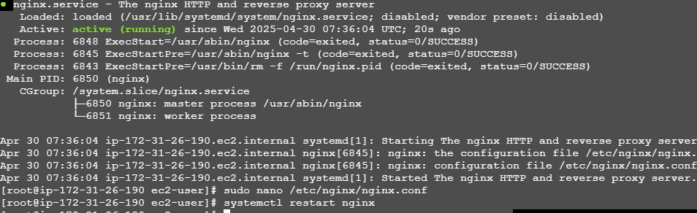



1. Deploy a sample index.html file on nginx.

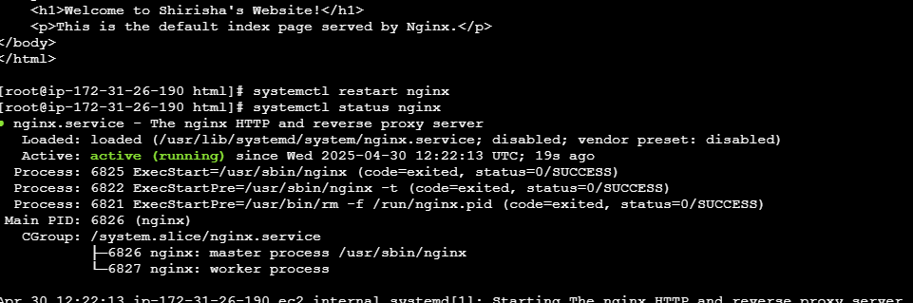



1. Install Apache and run Apache on port number 80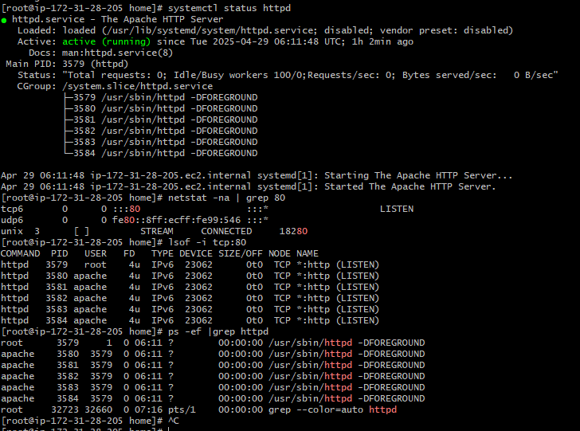

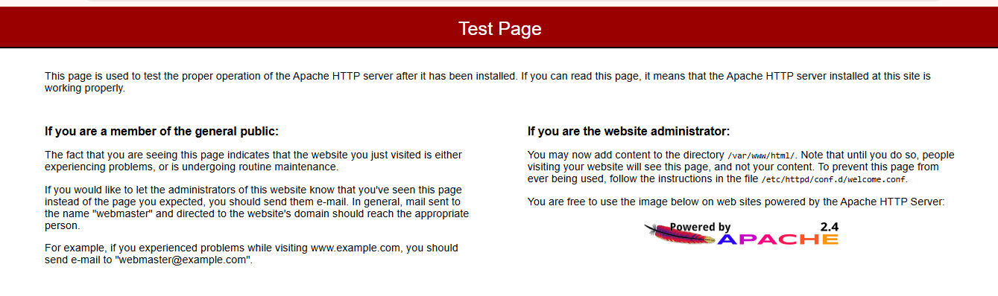

1. Deploy sample index.html file on Apache

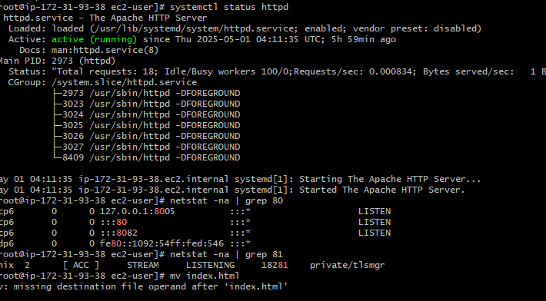

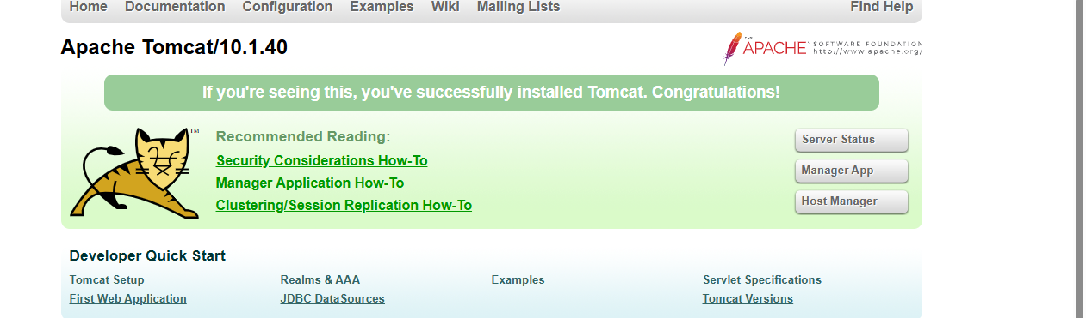

5) Install Apache tomcat on port number 8082

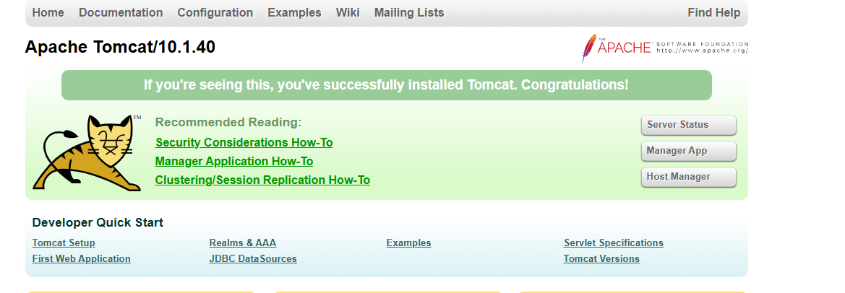

1. Deploy a sample app on webapps

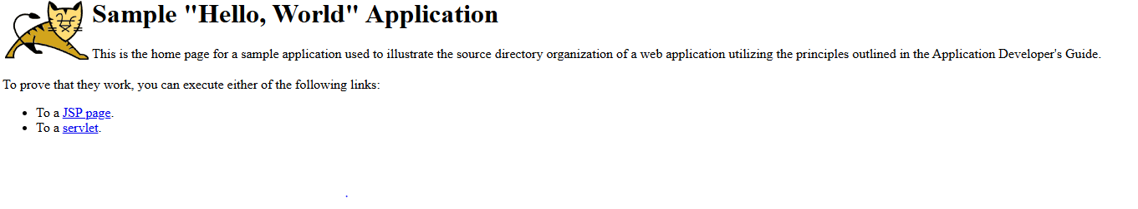

1. Create a tomcat.service file for tomcat.

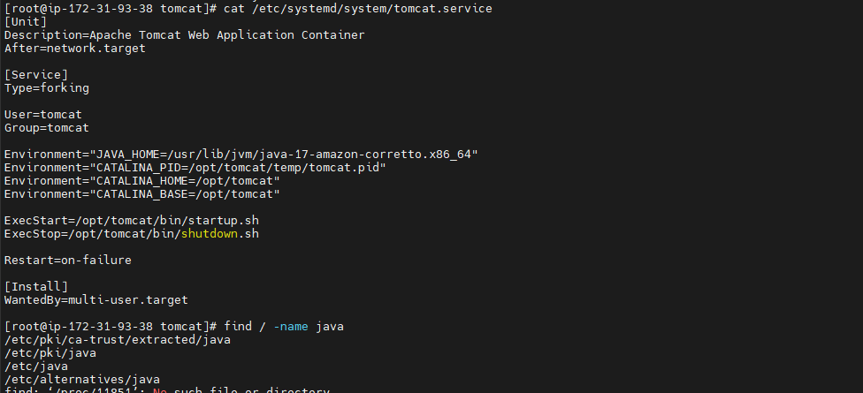

8) Configure HA Proxy server

